**INDOOR CHRISTMAS NOVELTY DOG SHOW**

**At the Larick Centre, Tayport**

**On Saturday 16th Dec 2023**

**10.30am to 12.30pm**

*(Dogs and handler’s registration 10am)*

Pete Appleby will be judging the classes.

Novelty Classes (Entry Fee for each category is £2, cash only please)

* A Star Is Born - Cutest Puppy (aged 6 to 12 months)
* Christmas Tree Topper - Best Golden Oldie (7 years+)
* Christmas Scrooge - Scruffiest Doggie
* I’m on Santas list - Waggiest Tail
* Most Twinkling Eyes
* Santa’s Helper - Best Trick
* Best Christmas Jumper (Dog and Handler)
* Christmas Cracker (Prettiest Princess)
* Shake Your Baubles (Most Handsome Prince)
* Best in Show (1st place from each class)

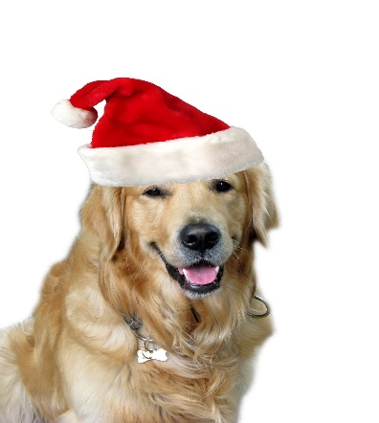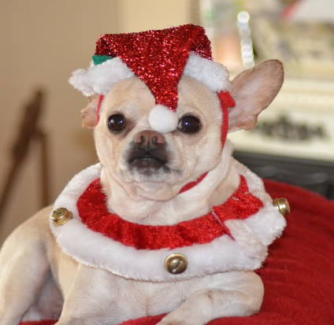

**All dogs MUST be on a lead.**  Registration Forms are available from the Larick Centre. Payment can be made on the day.