The Larick community Film Club Presents  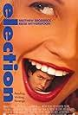  Election (Cert 15)  Starring: Matthew Broderick, Reese Weatherspoon  3 November, 4 - 6.30pm  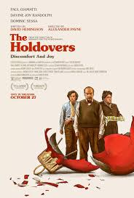  The Holdovers (Cert 15)  Starring: Paul Giamatti, Da'Vine Joy Randolph, Dominic Sessa  1 December, 4 - 6.30pm  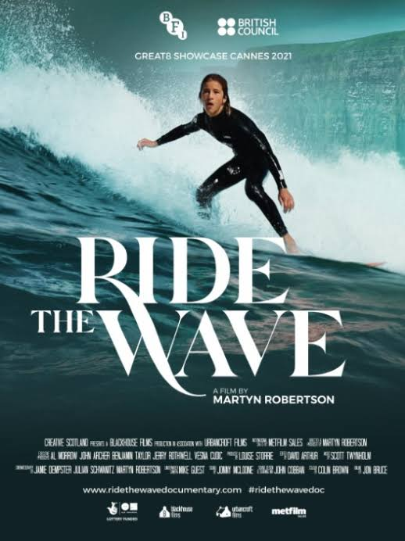  Ride the Wave (Cert 12A)  Starring: Ben Larg  12 January, 4 - 6.30pm  Where  Larick Centre  Shanwell Road, Tayport, DD6 9EA    larickfilmclub@tayportct.org.uk | 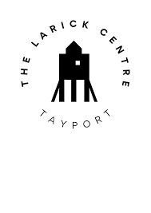  Tickets  Free event (suggested Donation): £5  Bookings  TBC  

